KE1E -

Functionality
You can transfer a sales plan created in CO-PA to Sales and Operations Planning (SOP).

You can transfer the sales quantities either by individual products or by product groups. You can use any profitability segments (for example, all products in a division) and time frames (posting periods and weeks) as selection criteria.

You can transfer a sales plan more than once, since the sales volumes are overwritten in SOP with each transfer. If you select the Transfer changes only field, you can ensure that only the changes are transferred when you have made changes to a CO-PA sales plan.

Scenario
Transfer Planned Sales Quantities to SOP for:
Company Code 5200
Plant 5200

Requirements
Plan data were entered into CO-PA.

Menu Path | Accounting → Controlling → Profitability Analysis → Planning → Integrated Planning → KE1E - Transfer Quantities to SOP
Transaction Code | KE1E

1. Double click on KE1E - Transfer Quantities to SOP.

Transfer Plan to SOP: Initial screen
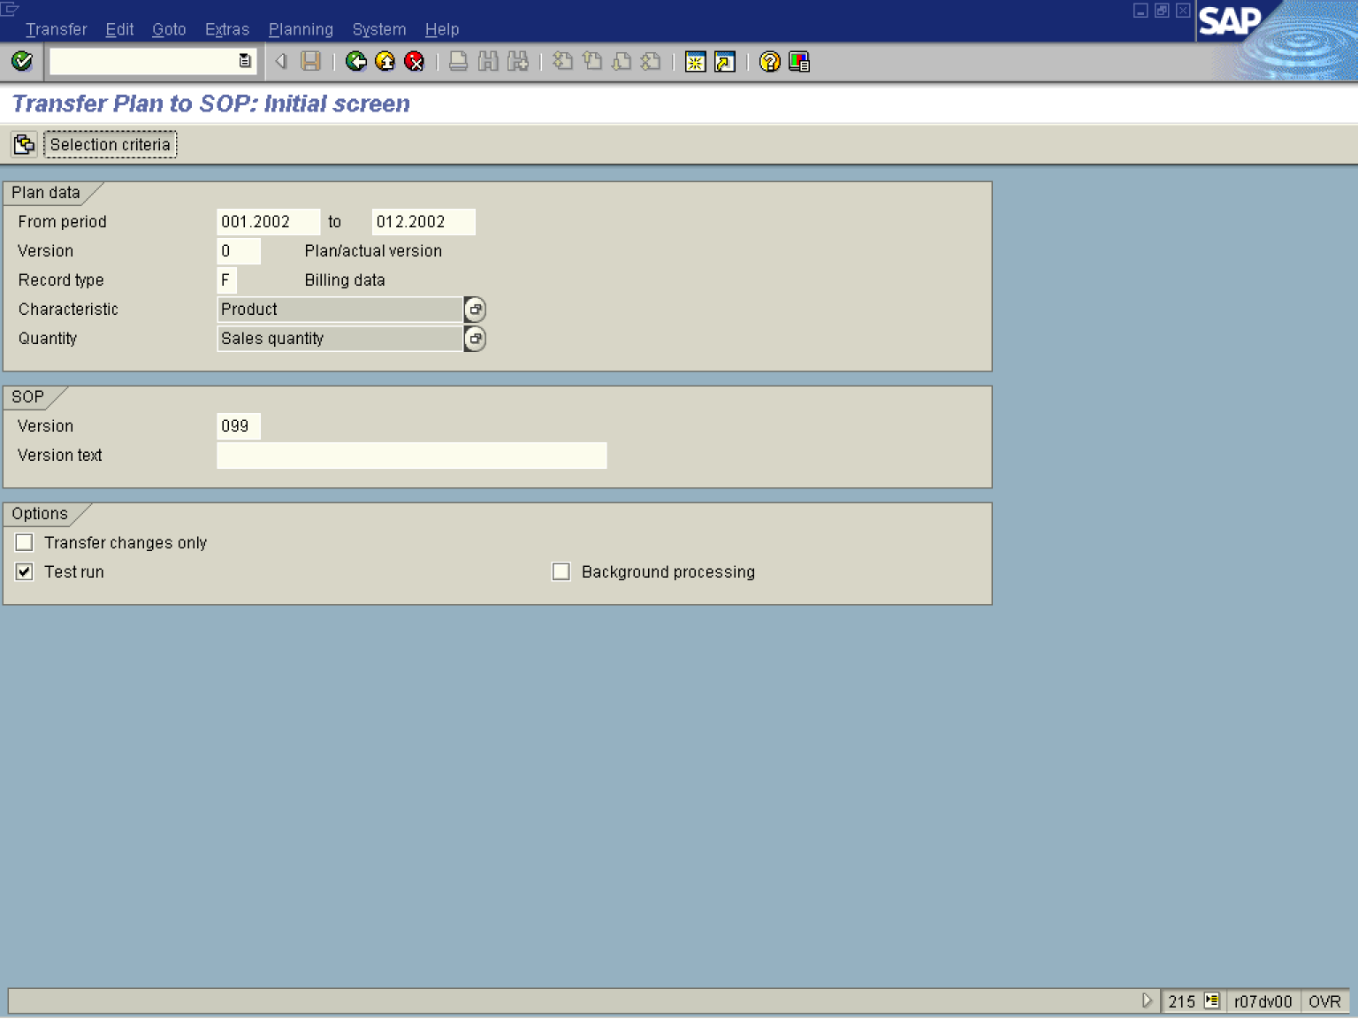

2. Update the following fields:

Field Name | Field Description | Values
From period | Entry field for beginning period and year. | Example: 001.2002
To | Entry field for the last period and year of the transfer. | Example: 012.2002
Version | Plan version (CO-PA) enables you to keep two or more sets of data for the same object. You can maintain and evaluate several plan versions at the same time. | Example: 0
Record type | Record types in CO-PA tell you what type of business transaction the data transferred to CO-PA comes from. | Example: F
Version | Version in SOP, a sales quantity plan can be stored in different versions. One of these versions is always 'active'. | Example: 099
3. Click the Enter button.
4. Click the Selection criteria button.

Transfer Plan to SOP: Selection criteria
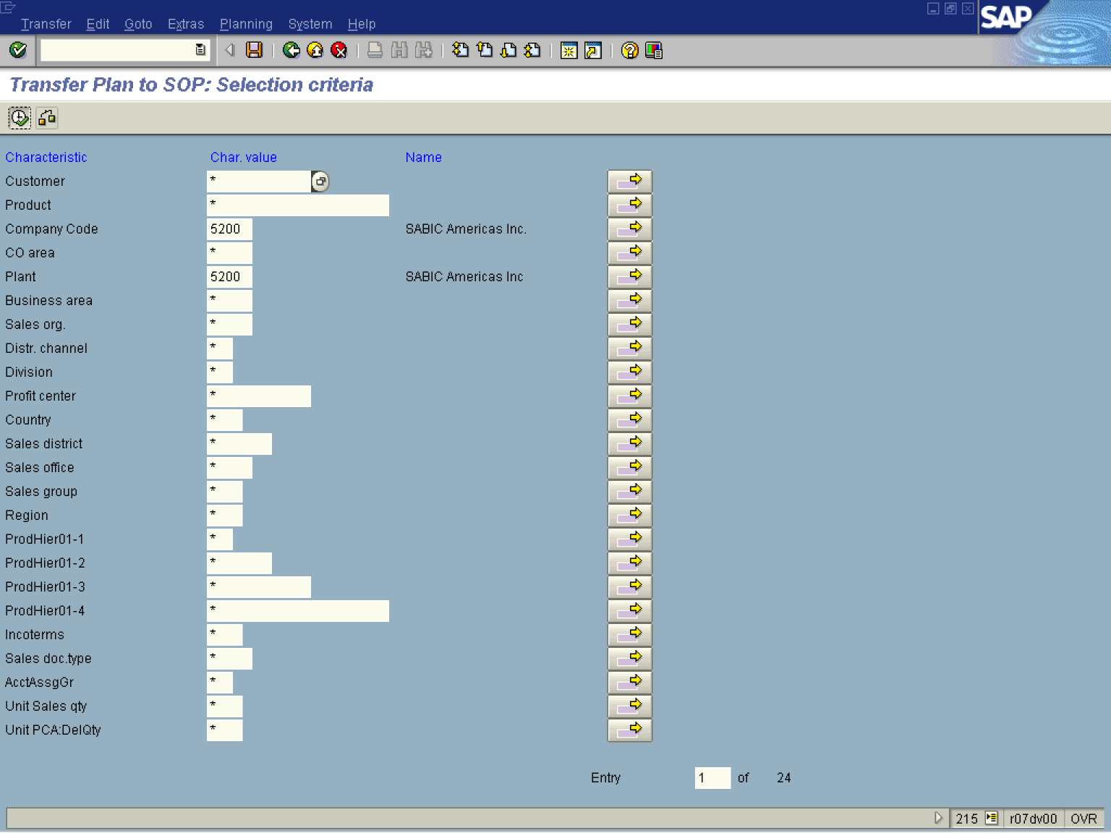

5. Update the following fields:

Field Name | Field Description | Values
Company Code | Code identifying the company. | Example: 5200
Plant | Code identifying the plant in which product is produced. | Example: 5200

6. Click the Enter button.
7. Click the Execute button.
Transfer to SOP: Log

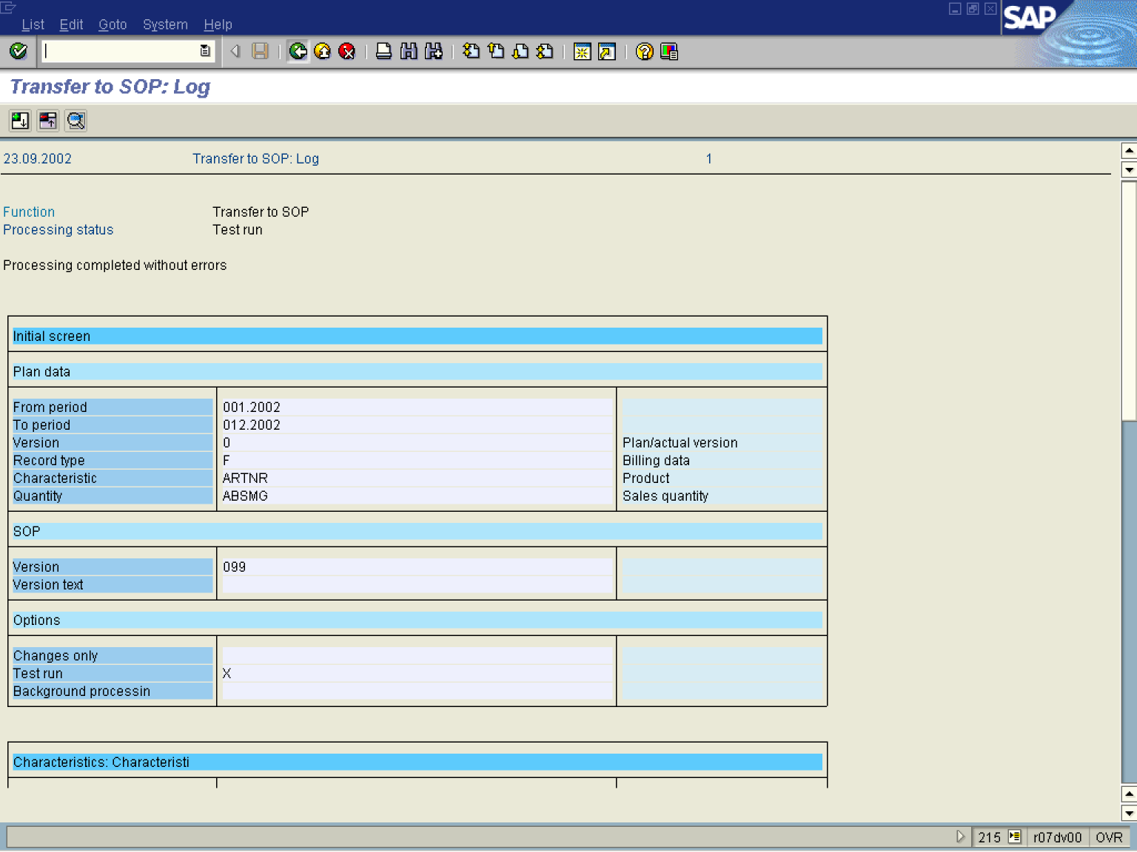

8. Click the Back button.

Transfer Plan to SOP: Initial screen

Note: You can transfer a sales plan more than once, since the sales volumes are overwritten in SOP with each transfer. If you select the Transfer changes only field, you can ensure that only the changes are transferred when you have made changes to a CO-PA sales plan.

9. If you are satisfied with the results, repeat the same process in Production mode by deselecting the Test run checkbox.

10. Click the Back button to go back to SAP Easy Access screen.

